Terrestrial Multi-Sensor Data Acquisition lab2

Data Acquisition and Sensor Analysis

|  |  |  |  |
| --- | --- | --- | --- |
| NAME | XIAO Tianqi | YANG Yihui | WANG Zhenqiao |
| ID | 3371477 |  | 3371590 |

1. Introduction

In this lab, we need to use a real sensor “Optical Speed and Distance Sensor” to get data and process it in MATLAB. In the end, we get the offset, the transfer factor and the deviations of them.

2. Extension of sensor module

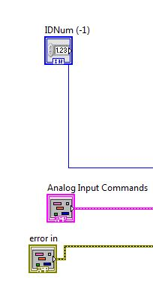

In last lab, we read from a txt file, but now we connect to a real sensor and have an analog input.

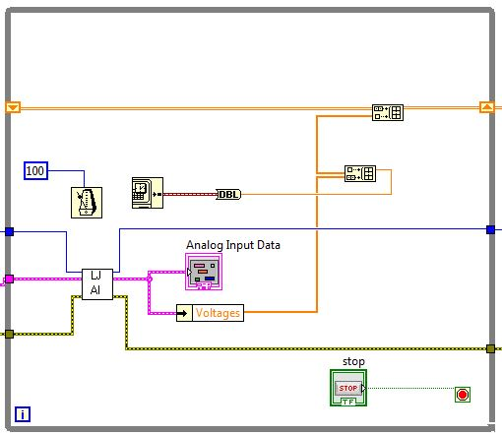

We use loop to read data continually and the stop button is to end it. “labjackAD.vi” is provided for us. Then use the “Unbundle by Name VI” to access the value “Voltages” from the output cluster.

Also to reach an equidistant sampling rate, the timer is reserved. “Get Date/Time In Seconds” and “To Double Precision Float” are used for timestamp.

We build an array to store our output which are the timestamp and velocity respectively.

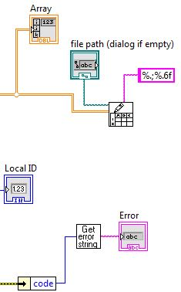

For output, considering we still need to process data in matlab, we convert the comma “,” in german version to “.” And write it to a file.

The front panel is

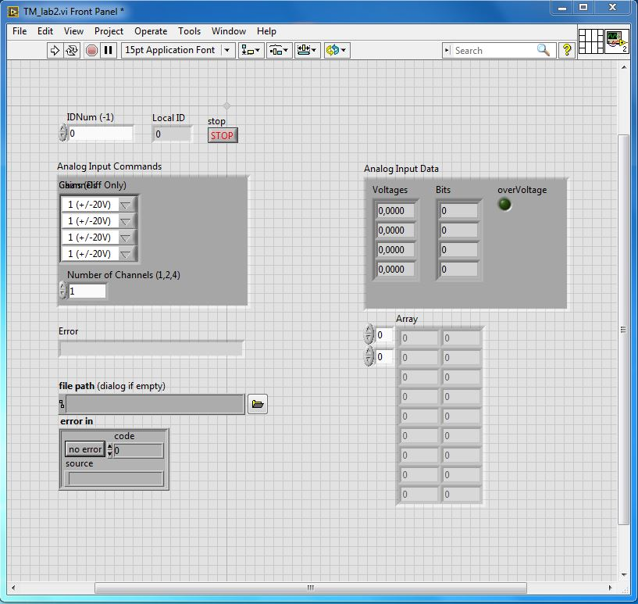

3. Sensor calibration

We hold our sensor still for how long to get the offset and decide to choose how long as our calibration data. The result is $k_{0}=0000[v]$

The standard deviation of offset is

$$σ_{k_{0}}=\sqrt{\frac{1}{N-1}\sum_{i=1}^{N}{{\left(X_{i}-k_{0}\right)}^{2}}}=00000[v]$$

The corresponding transfer factor k is derived from

$$k=\frac{d_{ref}}{\sum{\left(X-k_{0}\right)∙\frac{1}{N}∙∆t}}$$

We measured how many times, so we have

K de mei ge zhi

The mean and standard deviation of k are

$$k_{mean}=0000\left[v\right]$$

$$σ_{k}=0000$$

So the transfer function is

$$v=k∙\left(X-k_{0}\right)=000∙\left(X-0000\right)$$